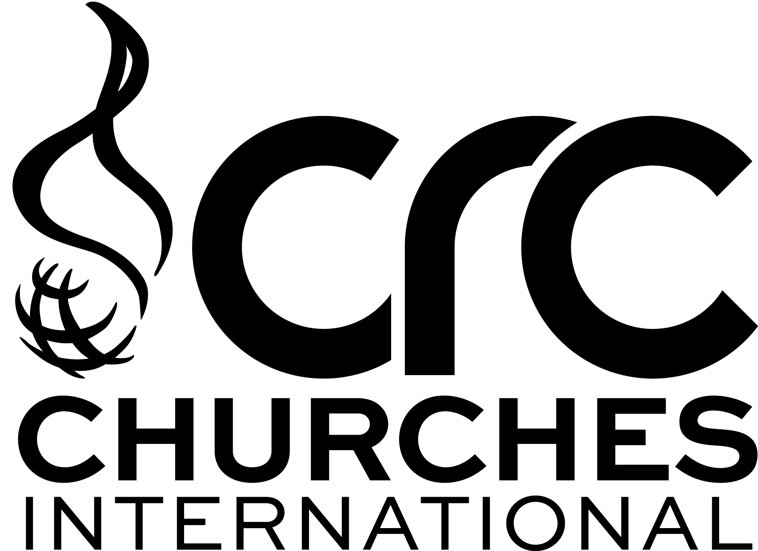
Details for Directory.

The details that appear in the directory will based on the information in this form.
If any details change please complete this form and advise the CRC National Office

Please email this form to crc@crcchurches.org
or by post to:
CRC Churches International
185 Frederick Road, Seaton, SA, 5023
SURNAME:
FIRST NAME:
TITLE: | Pr
CHURCH:
SENIOR MINISTER:
BIRTH DATE:
SPOUSE FIRST NAME:
SPOUSE TITLE:
SPOUSE BIRTH DATE:
WORK PHONE NO:
RESIDENTIAL ADDRESS:
RESIDENTIAL SUBURB/TOWN:
STATE:
POSTCODE:
RESIDENTIAL PHONE NO:
MOBILE PHONE NO:
SPOUSE MOBILE:
E-MAIL ADDRESS:
POSTAL ADDRESS:
POSTAL SUBURB/TOWN:
STATE:
POSTCODE:
CREDENTIAL HELD:
RETIRED: | YES/NO
Date First Credentialled:

